**Experiment no. 2**

Aim: Application of the Agile process models.

Problem Statement: To apply Kanban model for development of E-commerce shopping website.

Theory:

Kanban Model:

Kanban is a visual system for managing work as it moves through a process. Kanban visualizes both the process (the workflow) and the actual work passing through that process. The goal of Kanban is to identify potential bottlenecks in your process and fix them so work can flow through it cost-effectively at an optimal speed or throughput.

In our Kanban Board work pass flow through three process: To Do, In progress and Done. workflow from To Do to In progress to Done.

1) To Do contain all the things that are need to be completed in near future but not started yet.

2) In progress (Doing) name implies itself, work in progress limit (WIP Limit) which define maximum number of work can be there at a time and it also help us to increase our productivity, our WIP Limit is 6.

3) Done contain all the work which is completed, it track progress of our project.

Kanban Board:

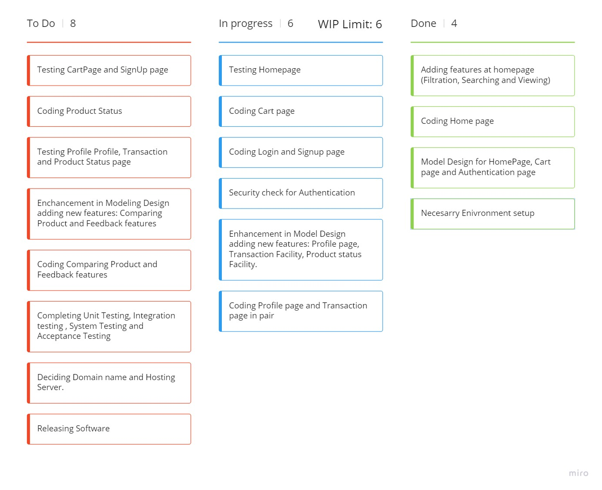

Conclusion: We have successfully applied Agile process model i.e. Kanban model for development of E-commerce shopping website.